E-Commerce Sales and Customer Segmentation Analysis Using Python

Project Report

Prepared by: Bhumireddy Chandana

1. Project Overview

This project analyses transaction-level online retail data to understand revenue performance, sales patterns, product and country contribution, and customer behaviour. The workflow combines exploratory data analysis with customer-level RFM analysis and K-Means clustering.
The executed analysis uses the actual OnlineRetail.csv dataset. After cleaning, the dataset contains 392,732 usable transaction rows. The notebook calculates all reported values from the data.

2. Objectives
- Understand the structure, quality, and completeness of the online retail transaction data.
- Clean transactions and calculate Revenue from Quantity multiplied by UnitPrice.
- Measure total revenue, orders, customers, and unique products.
- Analyse sales by month, product, country, and customer.
- Build customer-level Recency, Frequency, and Monetary metrics.
- Use K-Means clustering to identify groups of customers with similar RFM characteristics.

3. Dataset Description
The project uses the Online Retail dataset. The local file OnlineRetail.csv contains transaction records with invoice, product, quantity, date, price, customer, and country information.
Dataset link: https://www.kaggle.com/datasets/carrie1/ecommerce-data

Dataset measure | Value
Original rows | 541,909
Original columns | 8
Fields | InvoiceNo, StockCode, Description, Quantity, InvoiceDate, UnitPrice, CustomerID, Country

4. Technologies Used
- Python
- pandas for data loading, cleaning, grouping, and tabular analysis
- NumPy for numerical transformations
- Matplotlib and Seaborn for charts
- scikit-learn StandardScaler for feature scaling
- scikit-learn KMeans for customer segmentation
- Jupyter Notebook for the complete executable workflow

5. Data Cleaning and Preprocessing
The notebook applies the following cleaning process:
- Removed 5,268 duplicate rows.
- Identified 9,251 cancellation records using InvoiceNo values beginning with C, then excluded cancelled transactions from sales analysis.
- Converted InvoiceDate to datetime and Quantity, UnitPrice, and CustomerID to numeric forms where required.
- Removed rows with missing Description and missing CustomerID because they cannot support the corresponding product or customer analysis.
- Removed invalid dates, quantities, and prices, and retained positive quantities with non-negative prices.
- Created Revenue using Quantity multiplied by UnitPrice.
Cleaning measure | Observed result
Cleaned rows | 392,732
Cleaned columns | 11
Cancelled records identified | 9,251

6. Exploratory Data Analysis
The notebook reviews the first five records, dataset shape, column names, data types, missing-value counts, and duplicate rows. It then uses tables and visualisations to examine monthly revenue, top products, top countries, customer orders, customer revenue, the elbow curve, and RFM cluster summaries.

7. Sales Analysis

Basic Sales Summary
Metric | Calculated value
Total revenue | £8,887,208.89
Total orders | 18,536
Total customers | 4,339
Total unique products | 3,877

Monthly Sales Analysis
Revenue was highest in 2011-11 at £1,156,205.61 and lowest in 2011-02 at £446,084.92.
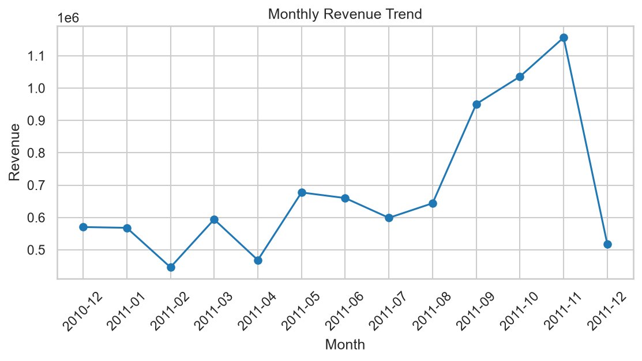
Figure 1: Monthly Sales Trend

Product Sales Analysis
Revenue is grouped by product Description and the top 10 products are displayed. The highest-revenue product was PAPER CRAFT , LITTLE BIRDIE with £168,469.60.
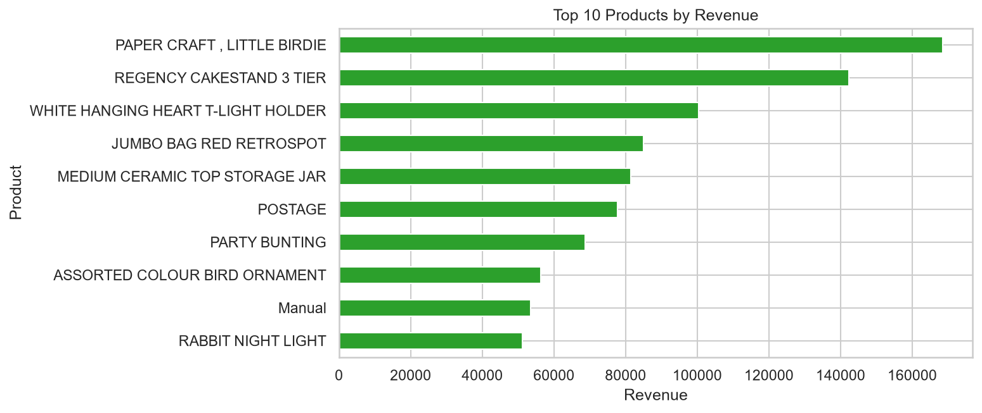
Figure 2: Top 10 Products by Revenue

Country-Wise Sales Analysis
Revenue is grouped by Country and the top 10 countries are displayed. United Kingdom generated the highest revenue at £7,285,024.64.
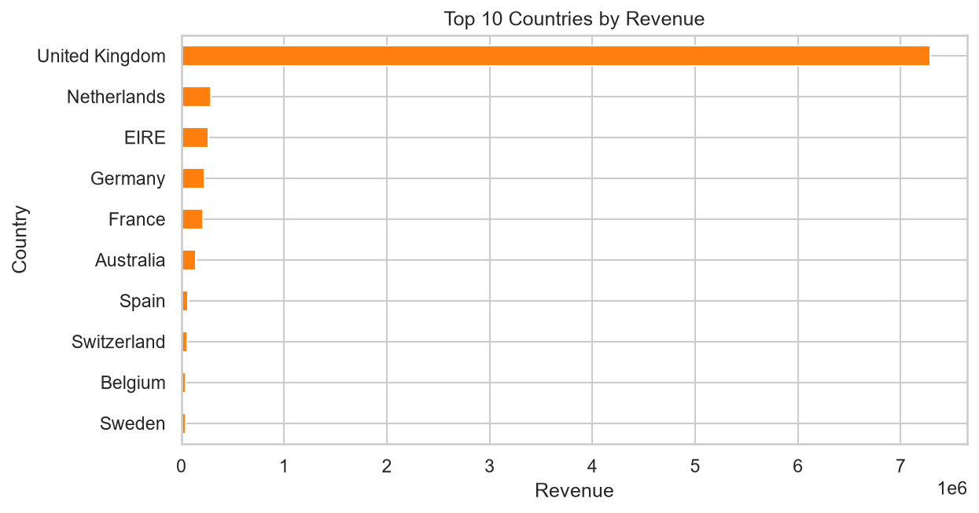
Figure 3: Top 10 Countries by Revenue

8. Customer Analysis
Customer analysis calculates unique orders and revenue per customer. The highest-revenue customer was CustomerID 14646 with £280,206.02 across 74 orders.
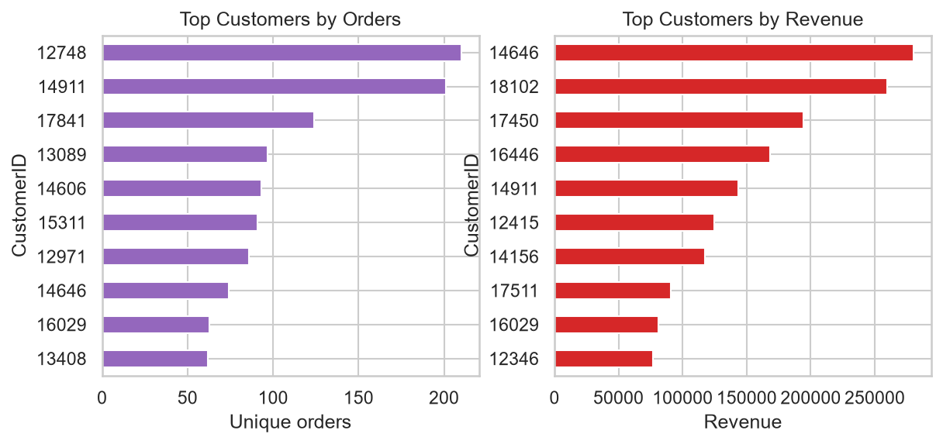

Figure 4: Customer Orders and Revenue Visualisation

9. RFM Analysis
RFM analysis creates one row per customer using Recency, Frequency, and Monetary value. Recency is the number of days since the most recent purchase, Frequency is the number of unique invoices, and Monetary is total customer revenue.
The latest observed InvoiceDate, 2011-12-09 12:50:00, is the reference date for Recency. The RFM features are transformed with log1p to reduce skewness and standardised with StandardScaler before clustering.

10. K-Means Customer Segmentation
K-Means is used as the unsupervised machine learning method. Candidate cluster counts are evaluated with the Elbow Method, then K-Means is fitted with random_state=42 and n_init=10.
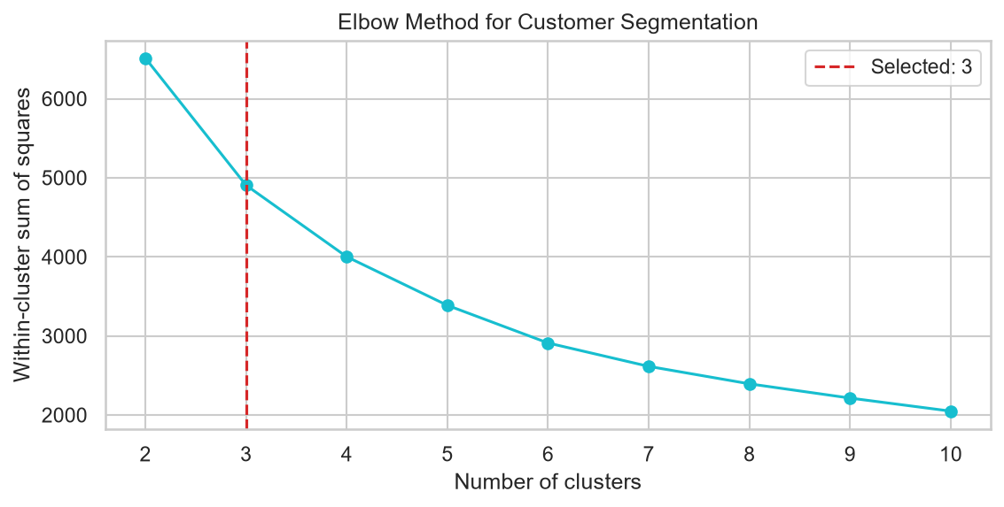
Figure 5: Elbow Method for Selecting the Number of Clusters

The elbow analysis selected 3 clusters. Cluster numbers are identifiers interpreted using their observed average RFM values.
Cluster | Customers | Average Recency (days) | Average Frequency (orders) | Average Monetary
0 | 729 | 12.93 | 13.67 | £8,016.79
1 | 1,922 | 161.14 | 1.34 | £352.00
2 | 1,688 | 46.19 | 3.55 | £1,401.91

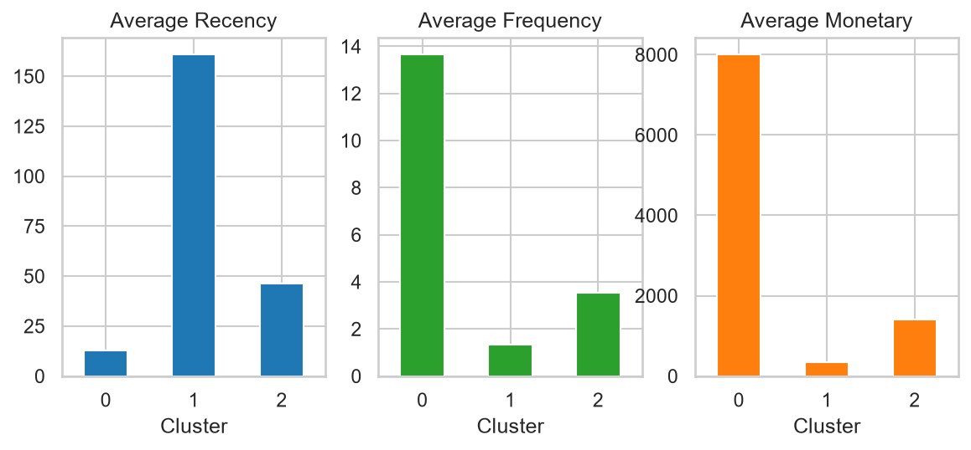Figure 6: K-Means Customer Cluster RFM Summary

11. Key Insights
- 2011-11 recorded the highest monthly revenue at £1,156,205.61, while 2011-02 recorded the lowest at £446,084.92.
- PAPER CRAFT , LITTLE BIRDIE was the highest-revenue product in the cleaned transaction data.
- United Kingdom was the highest-revenue country in the cleaned transaction data.
- CustomerID 14646 generated the highest individual customer revenue.
- Cluster 0 had the lowest average recency, highest average frequency, and highest average monetary value among the discovered clusters.
- Cluster 1 had the highest average recency and the lowest average frequency and monetary value.
- Cluster 2 represented an intermediate profile based on the displayed average RFM values.

12. Project Workflow
- Load OnlineRetail.csv from the notebook folder.
- Inspect structure, data types, missing values, and duplicate records.
- Clean transactions, identify cancellations, and calculate Revenue.
- Calculate sales summaries and create monthly, product, country, and customer analyses.
- Create the customer-level RFM dataframe.
- Log-transform and standardise RFM features.
- Use the Elbow Method and fit K-Means clustering.
- Summarise clusters and generate final insights.

13. Project Structure
- Chandana_EcommereceAnalysis.ipynb - complete analysis code, tables, charts, RFM workflow, and K-Means segmentation.
- OnlineRetail.csv - transaction dataset used by the notebook.
- requirements.txt - required Python libraries.
- README.md - project documentation.
- Chandana_ProjectReport.docx - this project report.

14. How to Run the Project
- Keep OnlineRetail.csv in the same folder as Chandana_EcommereceAnalysis.ipynb.
- Install the packages listed in requirements.txt in the selected Python environment.
- Open the notebook in Jupyter Notebook or Visual Studio Code.
- Select a Python kernel with the required packages.
- Run the notebook cells from top to bottom.
- Review the calculated tables, charts, RFM dataframe, elbow plot, cluster summary, and insights.
The notebook attempts UTF-8 encoding first and falls back to ISO-8859-1 when loading the CSV if required.

15. Conclusion
This project provides an end-to-end analysis of online retail transactions. It combines data understanding, cleaning, sales analysis, customer analysis, RFM feature preparation, and K-Means customer segmentation in one executable notebook.
The calculated results show how revenue is distributed over time, across products and countries, and among customers. The RFM clusters provide a structured view of observed customer behaviour based on recency, purchase frequency, and monetary value.

16. Future Scope
- Evaluate additional clustering configurations and compare their stability across repeated runs.
- Extend the analysis with more time periods when new transaction data becomes available.
- Compare cluster profiles over time to monitor changes in customer behaviour.
- Use the existing RFM segments as a starting point for future customer engagement analysis.

17. Dataset Reference
Online Retail Dataset: https://www.kaggle.com/datasets/carrie1/ecommerce-data
Local file used by the notebook: OnlineRetail.csv

